Digit-Eyes
Digit-Eyes is a software app that runs on the iPhone or iPad3. Digit-Eyes reads bar codes and provides audio information about the items identified by the bar codes using the recording and voice features of the iPhone. People who have problems reading or writing conventional printed text can use Digit-Eyes to label items with barcodes and access information about products that others have labeled. This includes people who are blind or visually impaired, people who are not literate, people with dyslexia or those who have suffered strokes that make reading difficult.

Bar Code Backgrounder
Bar codes are digital codes that can be easily read by a machine. Digit-Eyes uses four types of bar codes:
Quick-Response Codes (“QR Codes”) can contain letters and numbers. They are often used to connect to websites, but they can actually contain any text or set of numbers. The code to the right, for instance, reads “Digit-Eyes enables people to identify and organize all sorts of things.” | 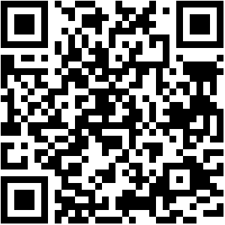  Digit-Eyes creates QR code labels.
Universal Product Codes (“UPC Codes”) are used to identify products for retail systems.  - The left portion identifies the company that has trade responsibility for the item  - The right portion is an item code that identifies the specific product.  UPC codes originated in the US and are typically 12 characters long, although there are abbreviated versions.  Adding another character to the left changes the UPC into a European Article Number (“EAN”) code. The extra digit makes it possible to identify the country where the party with trade responsibility is located. | 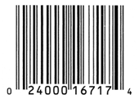  This code is for Del Monte (“24000”)  Peaches “16717”
Code 3-of-9 may contain both letters and numbers. This type of code is often used for inventory shelf tags. The example to the right is the same code number as the UPC code above it. | 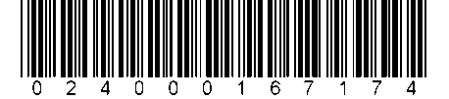
Code 128 may contain letters or numbers. This type of code is often used for serial numbers. | 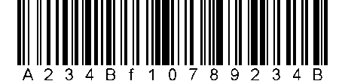

What does Digit-Eyes do?
Digit-Eyes enables people to:
- Create audio labels; which are QR code labels that can be used to create and play back audio recordings on the iPhone.
- Create text labels; which are QR code labels that contain text and that VoiceOver (the built-in audio reader on the iPhone,) reads aloud;
- Read and look up standard manufacturers’ barcodes in the Digit-Eyes database. Many manufacturers’ barcodes in the database link to nutrition information, detailed ingredients and usage instructions. If this information is available, it can be read aloud by VoiceOver.

Audio Label Examples
Use standard address labels and a regular computer printer to create barcode labels that can be scanned with an iPhone to trigger both recording and playback.  - It’s easy: just stick a label on something you want labeled: a CD, on a file folder or a favorite recipe.  - Scan the label with your iPhone and when it says “record,” talk as long as you like.  - When you scan the label again with your phone, you’ll hear your recording.  - If you get tired of it, just click the “re-record” button and make a new recording. | 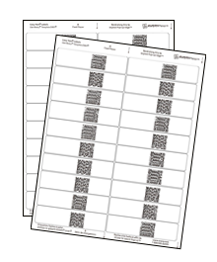
- Sticking a label on a pharmacy bottle makes it into a “talking bottle.” When your pharmacist is ready to tell you about the product, scan the label, say “tell me and my phone about this medication” and start recording. When you scan the bottle at home, you’ll hear everything the pharmacist told you.  - This recording is private and is stored only on your own iPhone. No one else can get to it.  - This feature is very helpful for people that have a hard time reading printed instructions but who find verbal instructions useful. | 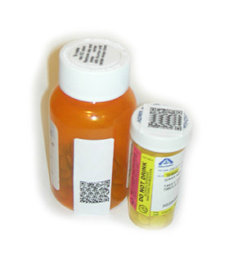
- We sell special labels that can be permanently attached to clothing or food containers and that can go through the washing machine and dryer, through the dishwasher or the drycleaners.  - Scan the label and record whatever you want to hear. For instance, you might record “this is spaghetti that I made on June 28” or “this is a red, white and blue plaid shirt. 50% cotton and 50% polyester. Wash medium, no bleach and dry hot, hang up immediately.”  - When you scan the label again with your phone, you’ll hear the recording.  - Run the item through the dishwasher, the laundry or send it to the cleaners. You’ll still be able to scan it and hear your recording.  - Want to change the information? Click “re-record” and that’s all it takes. | 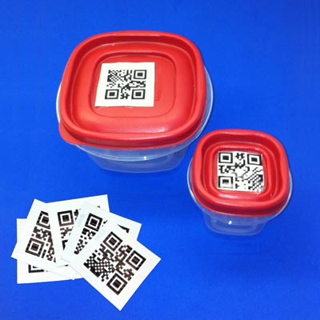

Text Labels
You can use the free features on the Digit-Eyes website, standard address labels and a regular computer printer to create bar code labels that contain text. These labels can be read aloud by your iPhone or iPad using the free Digit-Eyes reader. Now you can label file folders in an office shared by sighted or unsighted people, identify your preserves or put them anyplace you might otherwise hand-write a label. | 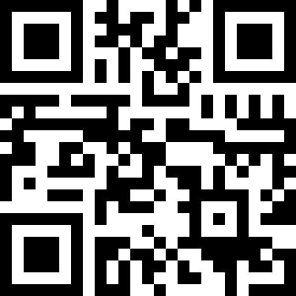  This label says “Strawberry Jam, June 2012”
The high-tech playing cards shown at the right can be read by the free version of Digit-Eyes. The codes read “Ace of Spaces”, “Ace of Diamonds”, etc.  Get the reader: http://digit-eyes.com/free/  Note: If you’re playing cards with others, earbuds or headphones are recommended!  http://digit-eyes.com/playingCards.html  Does your friend have an Android? They can still play! Readers for QR codes are available for the Android phone. https://play.google.com | 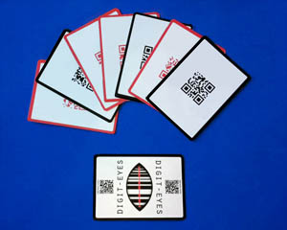

UPC/EAN codes
UPC codes identify products.  On the item shown at the left “57000” is the code for Campbell's Soup Company and "18049" is their code for the product inside the package.  When you scan a UPC code with Digit-Eyes, it is looked up in the Digit-Eyes database. The database currently has about 27,000,000 codes from around the world and it grows daily.  Digit-Eyes accesses the database over the Internet, so you always have the most current information. | 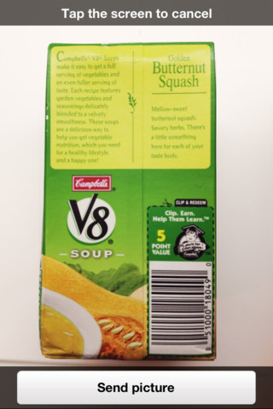
At the very least, Digit-Eyes will tell you the name of the product, but after scanning, you will probably have several opportunities to get more information about the product.  Links are provided, when available, to commercial sources to buy the item or to the manufacturer’s website.  Many items in the Digit-Eyes database also have a description, nutrition information, a list of ingredients or suggestions for use. | 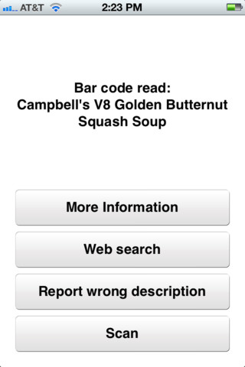
When this information is available, it is read aloud using VoiceOver as you pass your finger over the text. Any portion of it can be voiced as many times as you want. You can adjust the reading speed to be slow or fast.  Thus, by simply scanning the barcode, you’ll be able to find and hear more information about the product as it is read aloud by VoiceOver. | 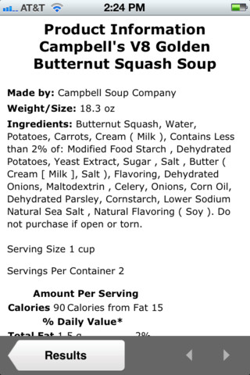

Additional Features of Digit-Eyes
Other Languages: Digit-Eyes is available 10 languages:  - English  - Spanish  - French  - Portuguese  - Italian  - Norwegian  - Swedish  - Danish  - Polish  - German  To change languages, simply use the “International” option in your iPhone settings and pick the language of your choice. | This is what you’d see if you scanned UPC 6 065890 00073 5, a can of Whiskas cat food labeled in Spanish.
For People who are Deaf-Blind: Apple products have useful solutions for people who cannot hear. Using the Bluetooth connection on the iPhone or iPad, a refreshable Braille display can be connected to the iPhone. Using this connection, people who are deaf-blind can use the tools and apps on the iPhone and iPad.

Advanced Accessibility on Apple Products
Apple devices are designed to provide access to people with disabilities. The accessibility features are free and are designed into the products.

For example
- The iPhone, iPad, iPod, and OS X include screen magnification;
- The iPhone, iPad, iPod, and OS X include VoiceOver, which is an audio-reader screen-access technology for the blind and visually impaired;
- To assist those with cognitive and learning disabilities, every Mac includes an alternative, simplified user interface that rewards exploration and learning.;
- For those who find it difficult to use a mouse, every Mac computer includes Mouse Keys, Slow Keys, and Sticky Keys, which adapt the computer to the user’s needs and capabilities;
- With the release of iOS4, the iPhone and iPad also support communication methods designed for people who have extremely limited mobility. This feature is called “assistive touch.” This is a useful tool for people who cannot use standard gesture languages and who access the device using a mouth stick or other pointing device.

For more information: http://www.apple.com/accessibility/

Getting Digit-Eyes
The Digit-Eyes software is available through the Apple App store. The price is $19.99. There is no charge for the database or for using the website http://digit-eyes.com | http://digit-eye.com/get/
To get the version that is only used for UPC reading, install the free version and scan any UPC code.  You’ll have the opportunity to pay $9.99 and get a limited version. | http://digit-eyes.com/free/
Washable Labels: $19.99 for 50 labels: | http://digit-eyes.com/washableLabels/
Labels to print yourself: | Avery labels are available from Wal-mart, most office stores or online from Amazon.com.  We recommend Avery 6570 labels because there are 32 per sheet.

Questions? Please email support@digit-eyes.com, ask for our Skype address or telephone (US) 817-571-3083

